Amazon Rekognition

Automate your image and video analysis

Case Study



**What is Amazon Rekognition?**

Amazon Rekognition makes it easy to add image and video analysis to your applications. You just provide an image or video to the Amazon Rekognition API, and the service can identify objects, people, text, scenes, and activities. It can detect any inappropriate content as well. Amazon Rekognition also provides highly accurate facial analysis, face comparison, and face search capabilities. You can detect, analyze, and compare faces for a wide variety of use cases, including user verification, cataloging, people counting, and public safety. Amazon Rekognition is based on the same proven, highly scalable, deep learning technology developed by Amazon’s computer vision scientists to analyze billions of images and videos daily. It requires no machine learning expertise to use. Amazon Rekognition includes a simple, easy-to-use API that can quickly analyze any image or video file that’s stored in Amazon S3. Amazon Rekognition is always learning from new data, and we’re continually adding new labels and facial comparison features to the service.

Identify the Object and things in an Image Using AWS Lambda and AWS Rekognition.

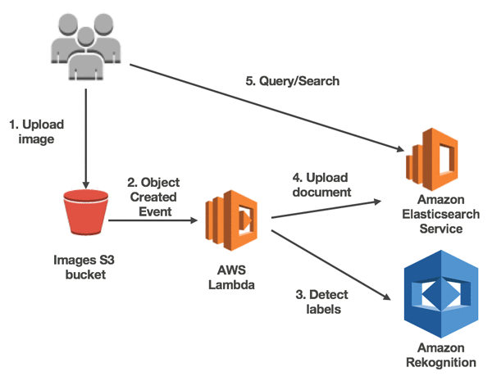

1. Open AWS Rekognition in AWS Console
2. Use custom labels option In that
3. Step one Create project
4. Create dataset and upload in S3 bucket (Image dataset better to keep in different folder of images)
5. You can label images if you want to , but it automatically labelled it based on folder name
6. Then train model . it will take 30 min to 24 Hours to train model based on training dataset length.
7. Then evaluate model
8. Then we can deploy of use model.

Following steps to do hands on Amazon Rekognition.

**Step 1)**

Open Amazon AWS Management console and sign in into it

Search for Amazon Rekognition service in search bar and click on it.

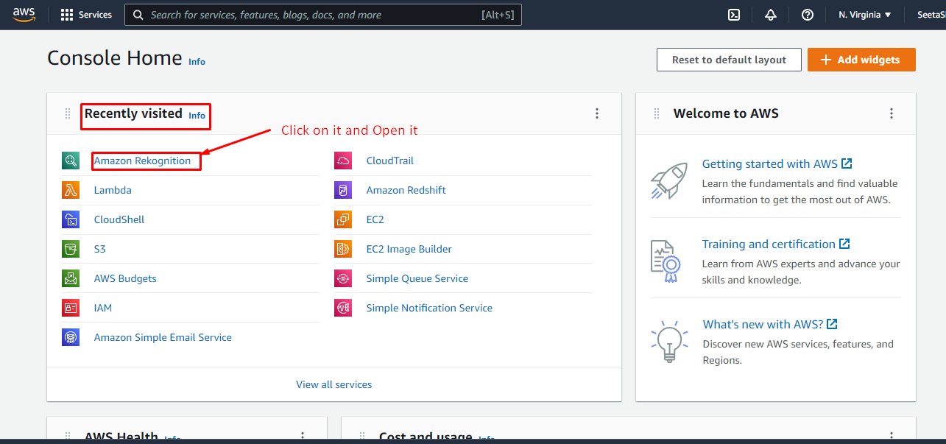

**Step 2)**

This is Dashboard of Amazon Rekognition

Click on left side bar on Custom labels inside that use custom labels

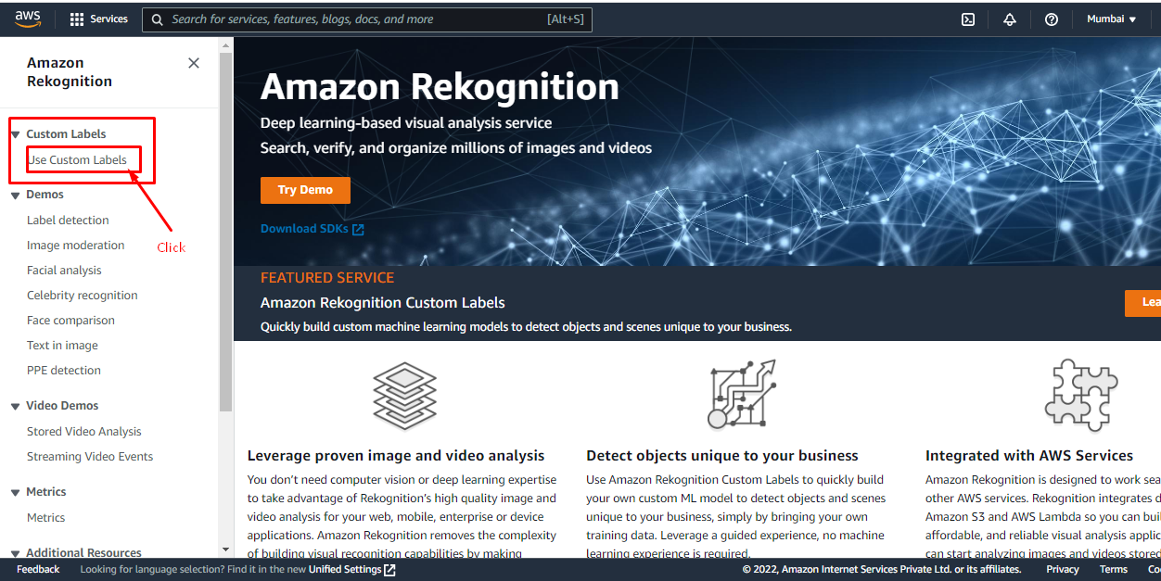

Click on Get started

And select the region

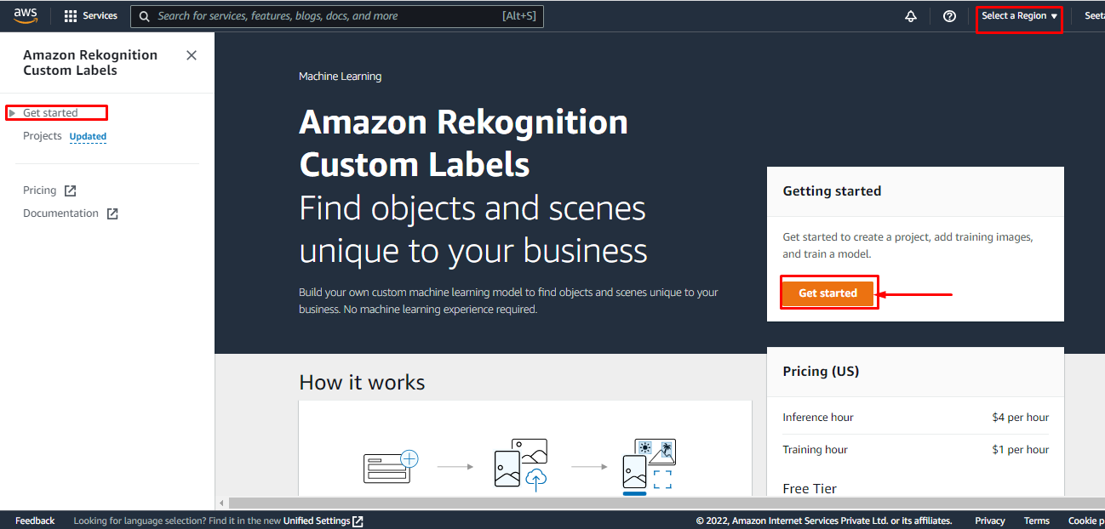

You can try to video tutorials and try for example projects

But lets create our new project

Lets On Project name which is under the Get started project of left hand side panel.

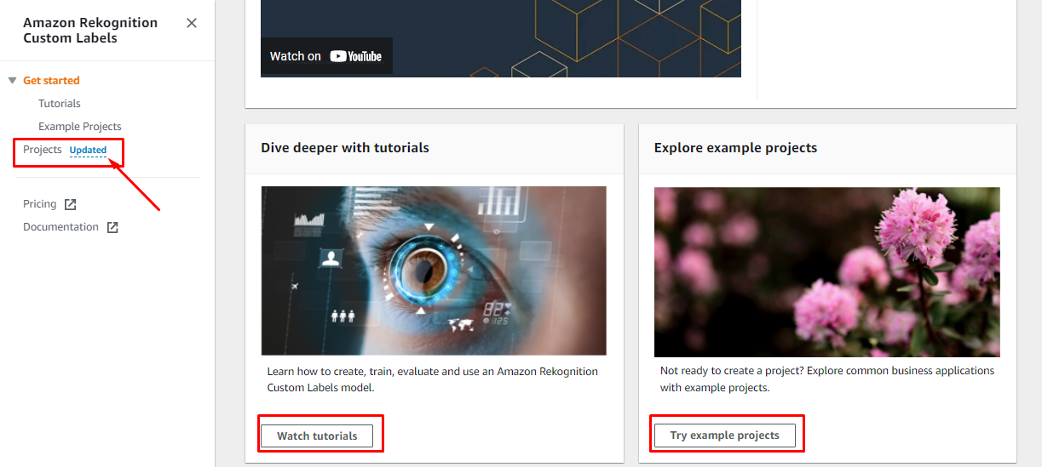

**Step 3)**

Click on Create project

As you can see the Region I have selected is Mumbai ap-south-1

Fill project details

Like name in this case or project is ma giving name as “Brain_tumour_recognition” as in this project I am using the brain tumour dataset as MRI Can Images of various tumour will occur in human brains and no Tumour MRI scan Images also.

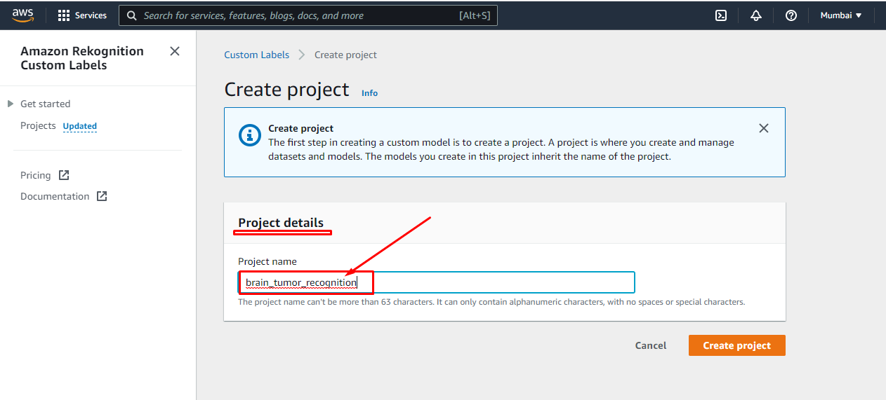

It will suggest you the steps to build your project

1.Create Dataset

2.Label images

3.Train Model

4.Ckeck Performance.

**Step 4)**

While creating or starting the project in amazon Rekognition requires an S3 bucket so it will ask you to create a bucket , So just click on create S3 bucket and move on

You can see in Amazon S3 one bucket is created there

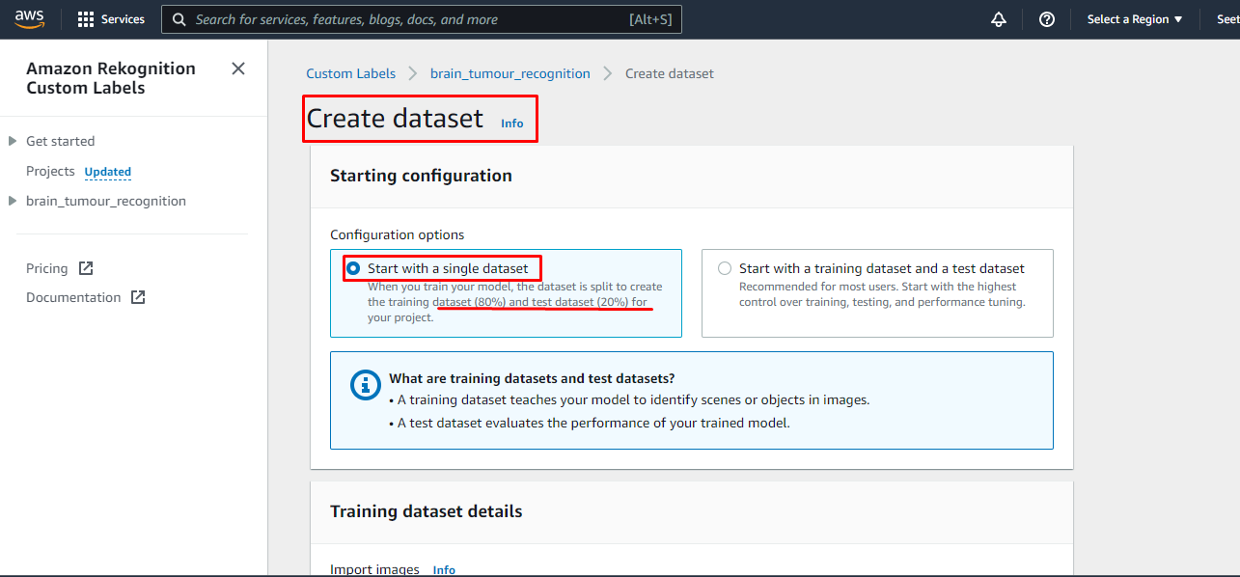

Import Image from S3 Bucket first As shown in Image.

Step 5)

Create New Folder in S3 Bucket , in that bucket we can store all images with its subfolders.

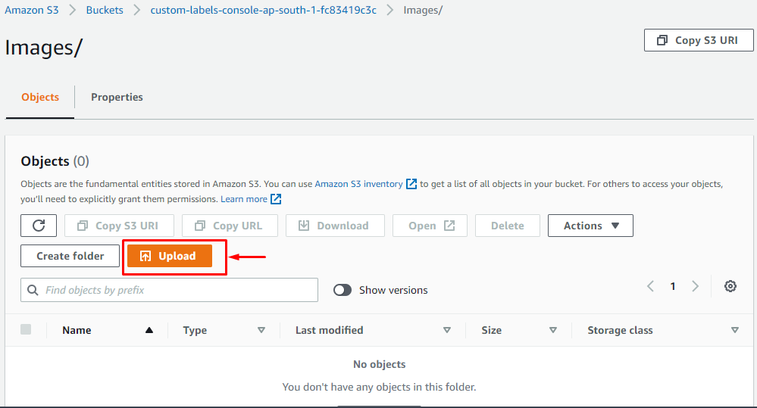

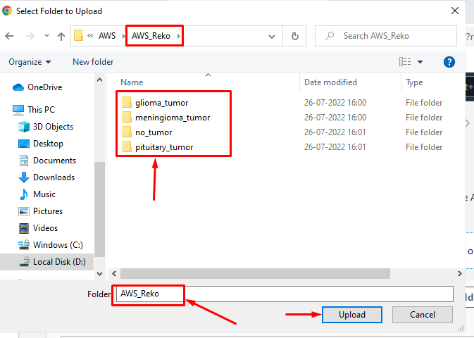

Each Folder Having Number of MRI scan Images of different type of Brain Tumours

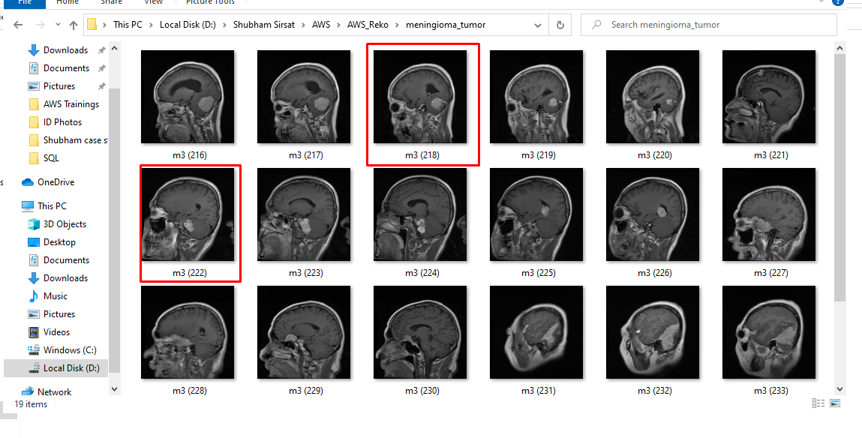

Click On Upload and

Your Images are uploading on S3 buckets.

**Step 6)**

Paste that URI link as shown in image for dataset input

Click on check box of Automatic Labelling that will automatically assign image labels based on folder name.

Click on Create Dataset.

You can see that dataset is created in our project

Labels images are there in dashboard, Number of Images also shown.

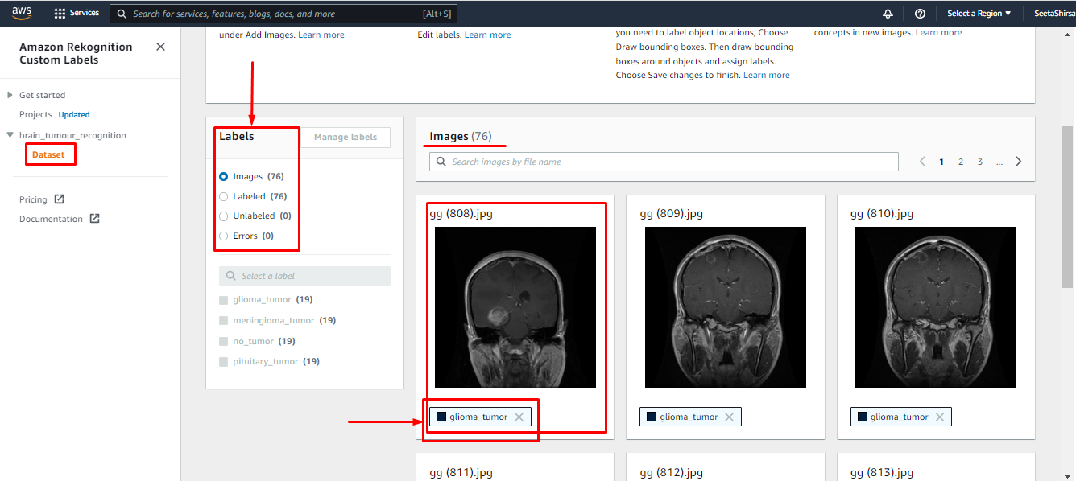

Click on Train Model

One dialog box will come with one message that is saying that typically training will take time from 30 minutes to 24 hours to complete.

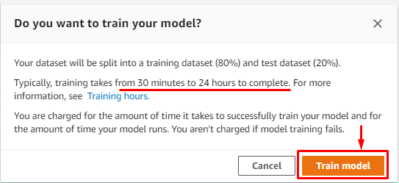

You can see the model is in training stage. = Training in Progress.

We have to wait for some time to model get trained.

You can View the test result in dashboard like F1 score , Avg precision, Overall recall

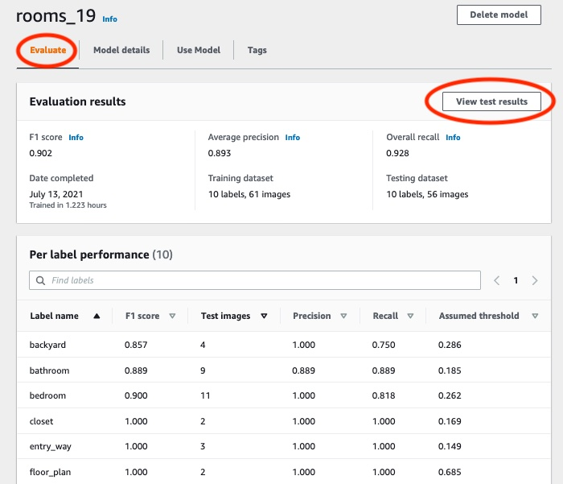

After Training your model we need to start the model to check the prediction.

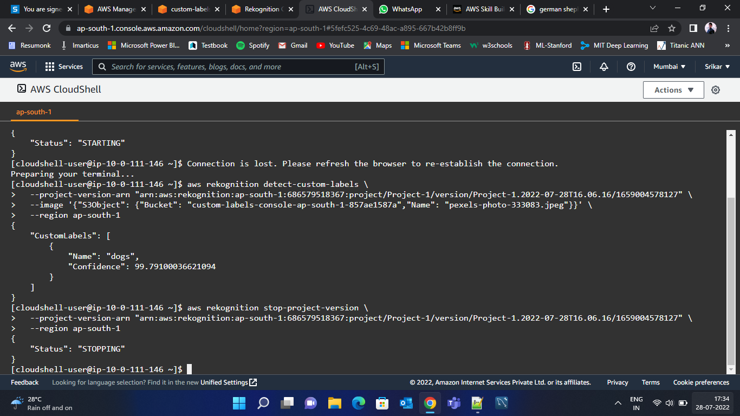

After completing our training and testing project if we have to delete our project or model we can delete it.

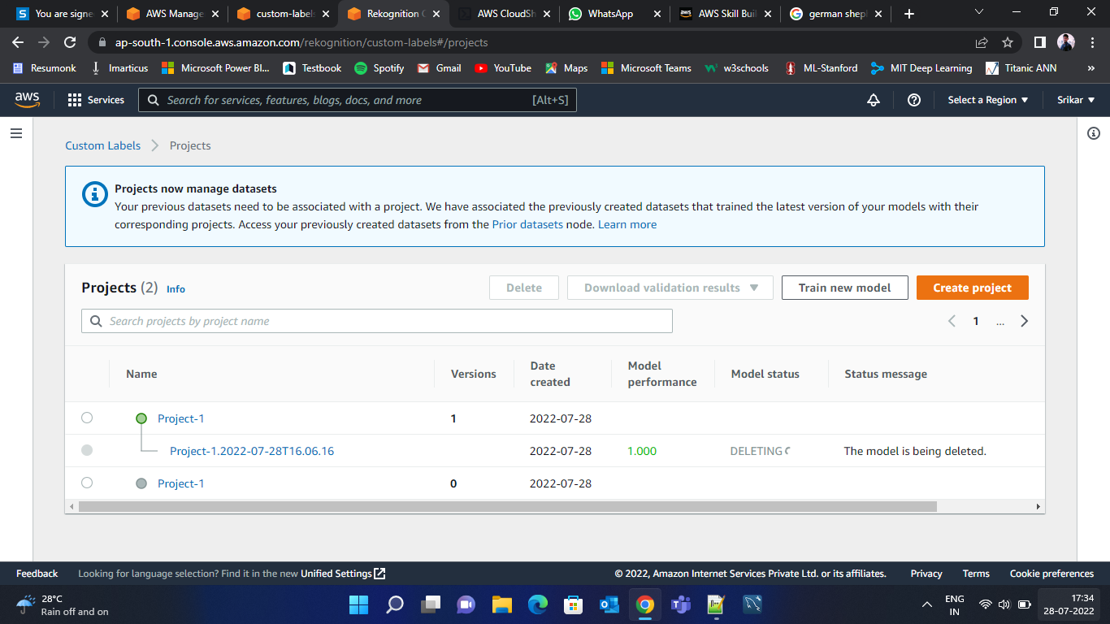

Click just select model in project >> click on one delete model button on upper right hand side of window then

Click on it.

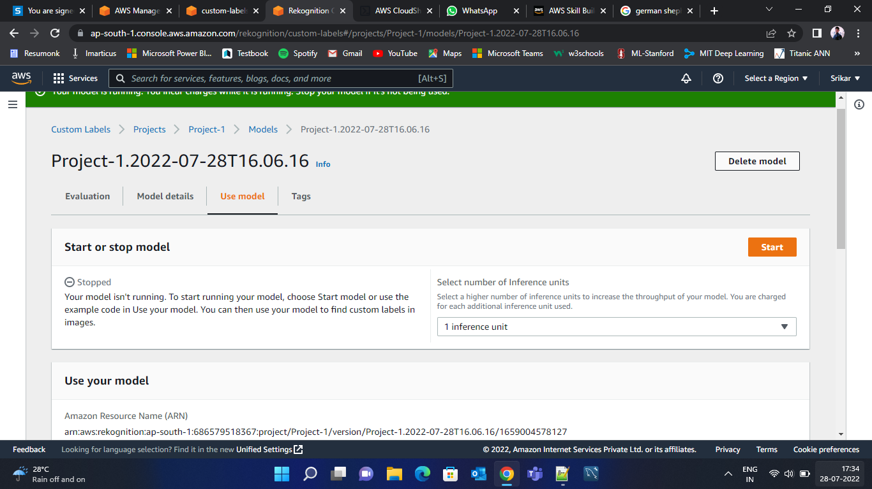

Click on Delete to confirm delete model.

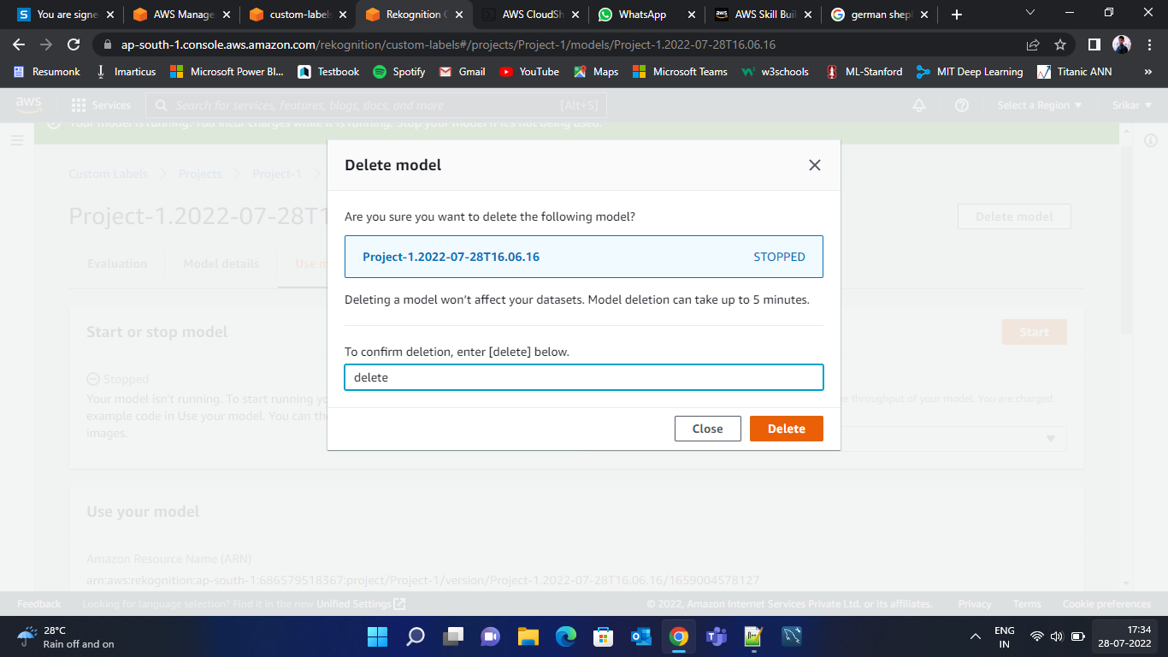

And your model is deleted

As same you can delete your project also.

**Use Amazon Rekoginition using Amazon Lambda function.**

Step 1) Create a IAM Role

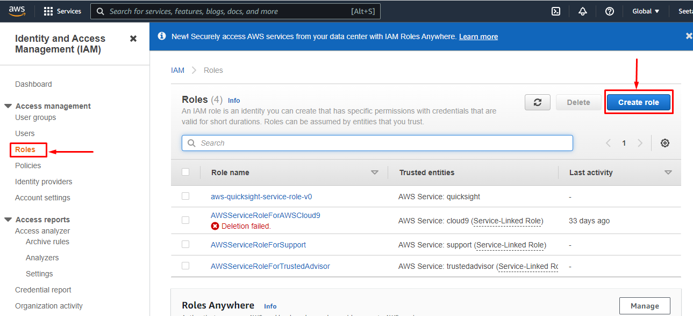

Step 2 ) Upload Object / Image in Amazon S3 Bucket

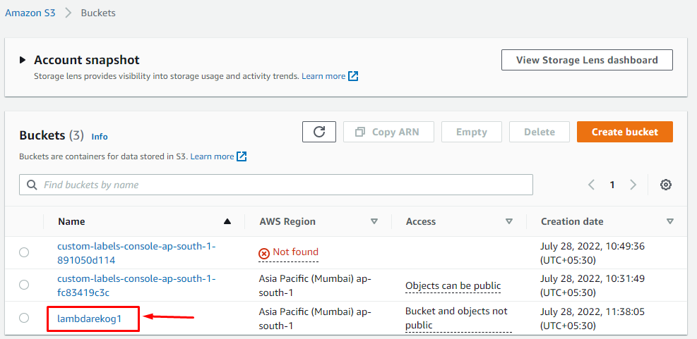

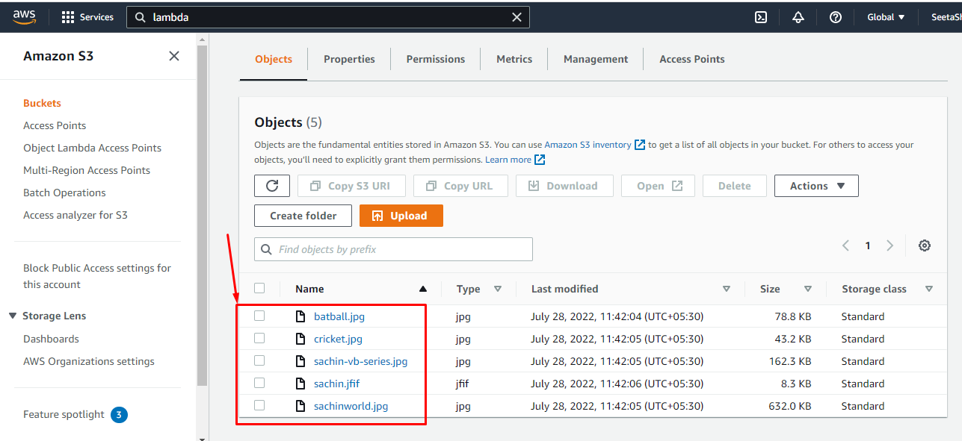

Images are uploaded in Bucket

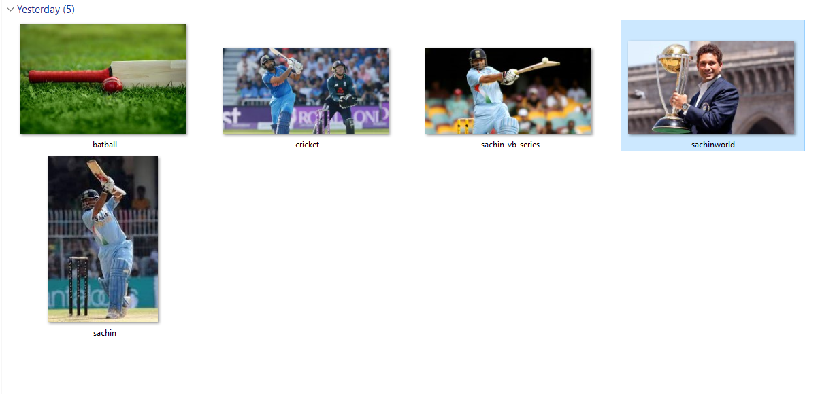

Step 3 ) Create a Lambda Function

Open Lambda service and Create New Function click on it.



